**Intelligent Systems Project**

**Yousef Sha’ban**

**This Project was made through researches on the internet, It contains this document, a power point presentation, and the program for the implemented controller, feel free to link the fis file to your program and experiment on it.**



It was a challenge, Since I couldn’t attend the lectures nor use the class materials because of the language barrier.

Hope it meets your expectations!

**INTRODUCTION**

Fuzzy systems are information-processing architectures based on fuzzy approaches, when the use of conventional set theory and binary logic is unfeasible or problematic. A fuzzy system may accept both linguistic values (specified by fuzzy sets) and crisp (numerical) data as inputs.[1]

So, since Mamdani System is extensively acknowledged for capturing expert knowledge. It permits us to describe the expertise in more intuitive, more human-like manner. [2]

**GOAL**

Our aim in this project is to make a water level controller using fuzzy logic and implementing Mamdani interface application.

**One of the first things that we might need a water control system is a fuzzy controller, so what are a fuzzy controller?**

Any plant controller's objective is to connect status variables to action variables. A physical system's controller does not have to be physical; it might be completely logical. In addition, where known correlations are hazy and qualitative. A Fuzzy logic controller can be built to implement a known heuristic.

In other words, the purpose of a fuzzy controller is to compute values of action variables from observations of the state variables of the process under control. [3]

**Classification of Liquid Level Controllers**

Level controllers are classified into numerous sorts. Among these are:

**A. Level Controllers**

Level controllers are devices that automatically manage the levels of liquids or dry materials. Level controllers can utilize three fundamental types of control functions: limit control, linear control, and advanced or nonlinear control.[4]

**B. Integrated motion controllers**

Controllers, motor drives, motors, encoders, user interfaces, and software are all part of integrated motion control systems. These systems' components are ideally matched by the manufacturer. They are usually tailored to specific uses. Pump Controllers.

**C. Pump controllers**

Manage pump flow and pressure output.

**D. Flow controllers**

Flow controllers allow the flow of fluid to be metered in one or both directions. Many of them let unrestricted flow in one direction while restricting or metering flow in the opposite direction.

**Modeling equations**

Using physics rules to create a mathematical model of the system to become the dynamic equation of the system, as shown in equations (1)& (2).

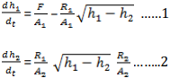

Where F is the steady-state liquid flow rate in cm3/sec, R1 and R2 are the coefficients in cm2.5/sec, h1 and h2 are the tank levels in cm, and A1 and A2 are the tank cross sectional areas in cm2.

**SYSTEM SIMULATION**

**1. Simulation Model of PID Controller**

* PID Controller Simulation Model Figure 3 depicts a simulation model of a conventional PID controller for liquid level management. In this simulation, we use a PID controller to manage the water level of the system. The valve has two inputs: control and source flow, which are connected by a limited integrator. The control valve is connected to the PID controller for controlling the outflow, and a constant is connected to the valve source flow for controlling the level. The valve output is given to the water tank, where we can observe the liquid flow out, water level, and overflow.

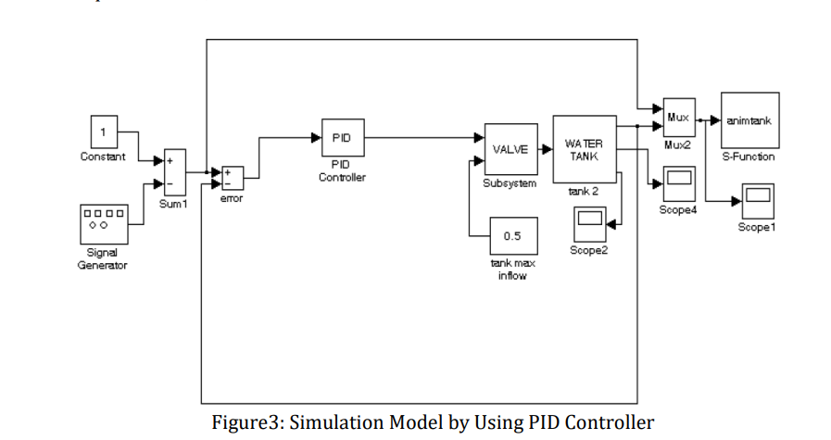

**Bear in mind that we won’t use a PID controller in this project, But here is the difference between both PID and FLC:**

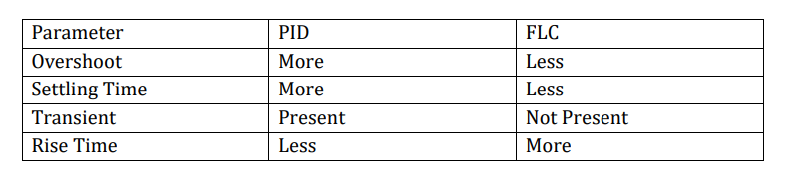

**SYSTEM SIMULATION**2. Designing of Fuzzy Logic Controller

**A. FIS Editor**

* For the Fuzzy Controller, we have defined two Inputs. The first is the level of water in the tank, marked as "Level," and the second is the rate of change of water in the tank, designated as "Rate." Both Inputs are used by the Rule Editor. According to the Rules defined in the Rule Editor, the controller acts and opens the Valve, which is the controller's output and is symbolized by "Valve."

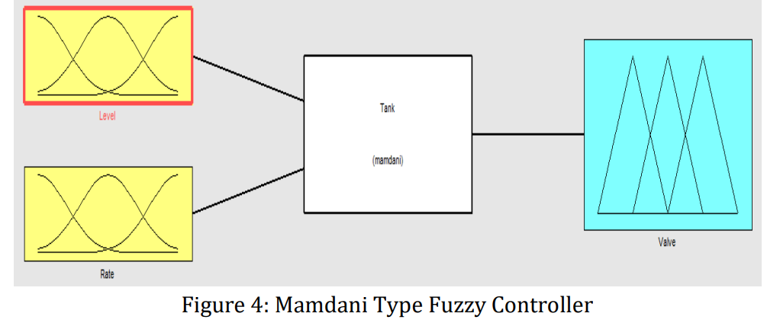

**B. Membership Function Editor**

* The Membership Function Editor shares some features with the FIS Editor. In fact, all of the five basic graphical user interface tools have similar menu options. The MF Editor is the tool that let you display and edits all of the membership functions associated with all of the input and output variables for the entire fuzzy inference system. When you open the Membership Function Editor to work on a fuzzy inference system that does not already exist in the workspace, there is not yet any membership functions associated with the variables that you have just defined with the FIS Editor.

**C. Simulation Model of Fuzzy Logic Controller**

* A simulation model of Fuzzy Logic Controller for liquid level control is shown in Figure:

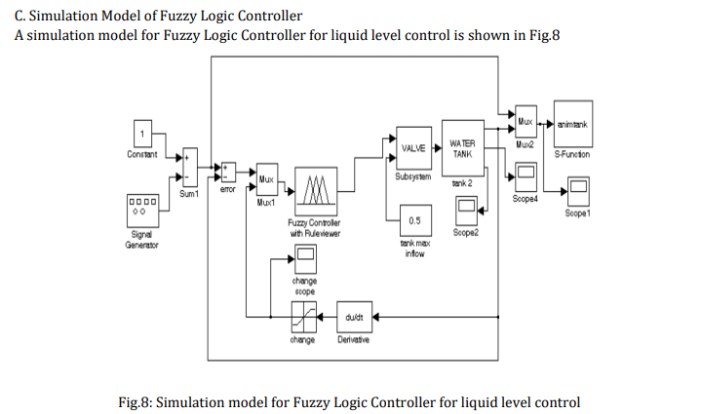

**5. RESULTS AND DISCUSSION**

* The graphs below show the Simulink results for the PID controller and the Fuzzy Logic Controller. Figure 9 depicts the simulated response of the PID controller. The controller rapidly stabilizes at the chosen water level. Figure 10 depicts the fuzzy controller's reaction when simulated with the supplied settings. The graph demonstrates that the controller overshoots and takes a long time to settle at the required value of 1m. Figure 11 compares the transient response of fuzzy and PID controllers for a target level of 1m (pink line shows PID and yellow one indicates fuzzy). The graph clearly shows that the PID controller has a larger overshoot than the fuzzy controller and also takes a long time to stabilize at the intended level. Fuzzy logic, on the other hand, has less overshoot and steady-state error and quickly stabilizes to provide accurate level control.

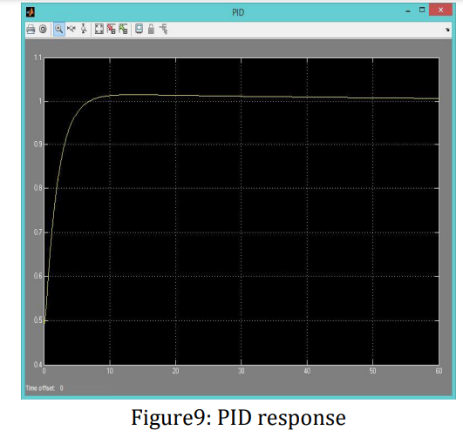 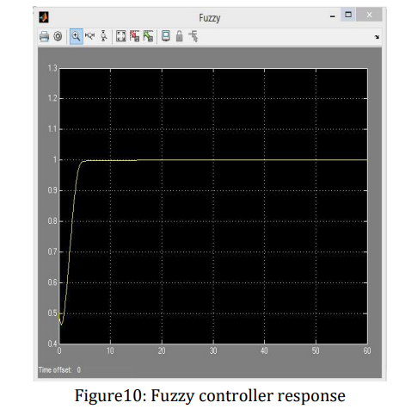

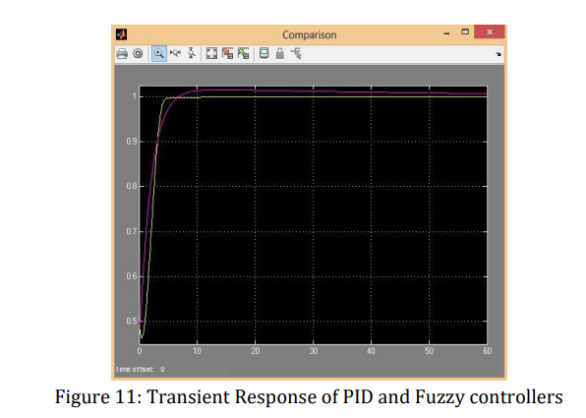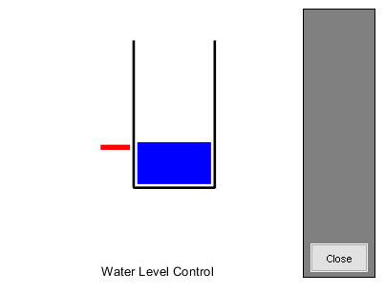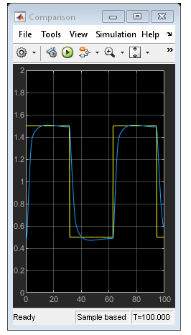

**CONCLUSION**

**We researched and simulated two approaches of managing liquid using SIMULINK. As a consequence of the comparison, it is obvious that fuzzy logic offers superior stability, a smaller overshoot, and a faster reaction than a standard PID Controller. As a result, it is the preferred method for managing fluid levels.**

**Bibliography**

**[1]** <https://link.springer.com/chapter/10.1007/978-3-319-59614-3_2>

**[2]** <https://www.mathworks.com/help/fuzzy/types-of-fuzzy-inference-systems.html#:~:text=In%20a%20Mamdani%20system%2C%20the,rule%20is%20a%20fuzzy%20set.&text=These%20output%20fuzzy%20sets%20are,methods%20described%20in%20Defuzzification%20Methods>.

**[3]** <https://www.sciencedirect.com/topics/engineering/fuzzy-controller>

**[4]** Q. Li, Y. Fang, J. Song, J. Wang, "The application of fuzzy control in liquid level system", “IEEE/ICMTMA”, Vol.3, pp.776-778, Mar. 2010